**FDS – ASSIGNMENT 1 – QUESTION 1-d**

We start with an initial image of a white dot over a black squared background.

Based on convolution theory and separability, it’s possible to write the convolution2D formula:

*conv2(conv2(img_imp, Gx, 'same'), Dx.T, 'same')*

as

*conv2(conv2(Dx.T, Gx, 'same'), img_imp, 'same')*

Dx is the gaussian derivative on x which returns positive values for each negative value of x and vice versa. Therefore, in the interval [-3σ, 3σ] of our case study, we get **positive** values for Dx for all negative values and **negative** values for all positive values.

x = [ -, -, -, -, …, 0, +, +, +, +…] → Dx = [ +, +, +, +..., 0, -, -, -, -…]

x = [ -, -, -, -, …, 0, +, +, +, +…] → Gx = [+, +, +, +…,0, +, +, +, +…]

The shape of Dx and Gx is (1, 2σ + 1). We transpose one of those two vectors to operate the convolution process, and obtain the (2σ+1, 2σ+1) kernel. In other words, (2σ+1, 1) * (1, 2σ+1) = (2σ+1, 2σ+1)

As an example, we will calculate the convolution over Gx.T and Dx:

$\left[\begin{aligned}+ \\ + \\ + \\ . \\ . \\ 0 \\ . \\ . \\ + \\ + \\ +\end{aligned}\right]$* [ +, +, +, +..., 0, -, -, -, -…] = $\left[\begin{aligned}+ , +, +, …0, -, -, -, … \\ +, +, +,…0, -, -, -,… \\ +, +, +,…0, -, -, -,… \\ +, +, +,…0, -, -, -,… \\ +, +, +,…0, -, -, -,… \\ +, +, +,…0, -, -, -,… \\ …\end{aligned}\right]$ →

The positive side of the kernel represents the higher weight (higher frequency) blurring the image (white noise in case of our white dot example), and the negative side of the kernel shows the lower frequency (the black side).

Plot 3

Plot 1

Plot 2

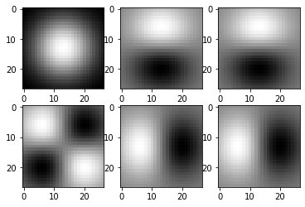

Plot 6

Plot 5

Plot 4

* **Plot 1**: we apply a simple Gaussian Filter Gx (no derivatives used). We convolve the signal of the image with Gx and GxT, making use of the separability property. Hence, the white dot remains at the center of the black square, it just gets blurred by the Gaussian Filter. The bigger is the value of Sigma, the wider the dot gets blurred and it is spread around the center.
* **Plots 2 and 3**: In this case we convolve the signal of the image with the vector of values of the Gaussian in each point of the given interval (Gx) and the transpose of the vector of values of the derivative of the Gaussian in each point of the given interval (DxT). Since the convolution has the property of commutativity, the result is the same for either Plot 2 and 3, regardless of whether we first convolve with Gx and then with DxT, or first with DxT and then with Gx. In both cases, the convolution with the Gaussian kernel only blurs the image, while the convolution with the transpose of the Gaussian derivative kernel blurs the image in the upper part and both blurs the image and inverts the grayscale values in the lower part.
* **Plots 5 and 6**: This time we convolve the signal of the image with the transpose of the vector of the Gaussian in each point of the given interval (GxT), and the vector of derivatives of the Gaussian in each point of the given interval (Dx). The convolution with the transpose of the Gaussian kernel only blurs the image, while the convolution with the Gaussian derivative kernel blurs the image in the left part and both blurs the image and inverts the grayscale values in the right part. Plots 5 and 6 are again equal because of the commutative property of the convolution.
* **Plot 4:** Plot 4 makes only use of the Gaussian derivative kernel and its transpose (Dx and DxT). We convolve the signal of the image with Dx and then with DxT. As a result, the convolution blurs the image in the upper left and lower right parts and both blurs the image and inverts the grayscale values in the upper right and lower left parts.

**FDS – ASSIGNMENT 1 – QUESTION 1-e**

By applying a Gaussian filter we get rid, from the signal of an image, of those frequencies that are too high, and therefore not representative of their own specific area of pixels. As a result, the noise in the image is reduced significantly, and it gets much easier to detect the so-called *edges*, that are those parts of the picture where fast changes in brightness happen (for example, a line representing the border between a red and a green object can be considered an edge).

We know that if we apply the first order derivatives of the gaussian function to the signal of an image, we can detect the edges as the points of local maxima. More specifically, by applying the partial derivative in x (Dx) we sharpen the image vertically, by applying the partial derivative in y (Dy) we sharpen the image horizontally.

What about diagonal edges? We use the gradient of the Gaussian function as Kernel for the edge detection filter (its components are the first order derivatives of the Gaussian in x and y): $\frac{∂f}{∂x}$, $\frac{∂f}{∂y}$.

Thanks to the gradient, we can now find the diagonal orientation of the edges, which corresponds to the direction of the gradient vector.

As an alternative, we can determine the second order derivatives of the Gaussian, calculated as

$$\left\|∇_{f}\right\|= \sqrt{{\left(\frac{∂f}{∂x}\right)}^{2}+{\left(\frac{∂f}{∂y}\right)}^{2}}$$

In such case, the edges correspond to the “zero crossing” points.

In the first and second image of the Assignment, the edges are detected along a given direction, vertical or horizontal, depending on which first order partial derivative is provided (Dx in the first image, Dy in the second).

In the third image the edges look clearer given that both partial derivatives are being taken into account, with the only difference that this time we are considering second order derivatives, therefore we are looking for zero crossings rather than local maxima.

**FDS – ASSIGNMENT 1 – QUESTION 3-c**

The goal of this exercise was to see how different combinations of distance functions, histogram functions and histogram bin numbers differ with respect to the recognition rate (the ratio between number of correct matches and total number of query images), and to find which one is the best.

For a large part of the (distance function, histogram function) combinations, reducing the number of bins from 30 to 10 raises the recognition rate up, while increasing it from 30 to 50 makes the recognition rate lower. We expected this result due to the increase (or decrease) in the granularity found in the number of bins variation.

For lower number of bins, the similarity would be a more approximate and rough measure, to the point where we might not be able to recognize them anymore.

For higher number of bins, there is an increase in granularity during the selection of an image similarity candidate. For each query image object there is a corresponding model image object, and the difference between the objects is found in an out-of-plane rotation, which results in different shadows and therefore different pixels values. To put it simply, differences add up quite quickly for high number of bins.

The best (distance function, histogram function, number of bins) combination is given by the intersection distance on RGB histograms with 30 bins, with results in a recognition rate of 0.8089887640449438

On average:

* The best distance function is the intersection, with a mean recognition rate of 0.669476 across all combinations of histogram functions and histogram bin numbers, while the worse one is the l2, with a mean recognition rate of 0.432584
* The best histogram function is the rgb, with a mean recognition rate of 0.571785 across all combinations of distance functions and histogram bin numbers, while the worse one is the grayvalue, with a mean recognition rate of 0.441948
* The best choice regarding the number of bins is 10, with a mean recognition rate of 0.576779 across all combinations of distance functions and histogram functions, while the worse one is 50, with a mean recognition rate of 0.472846

Following are some results we have got from the different methods we have available for different number of bins.

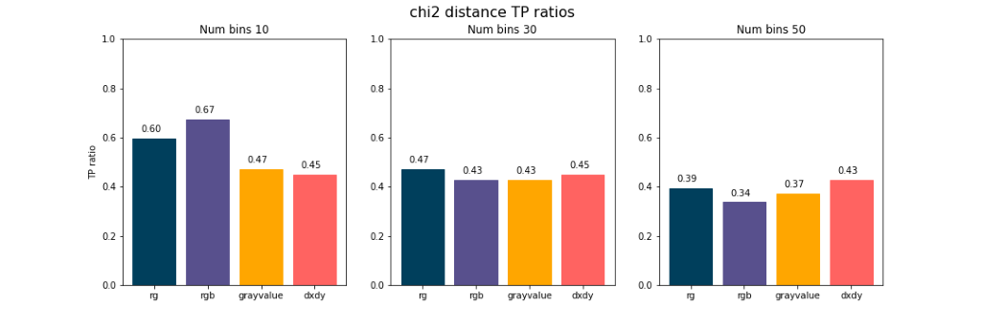

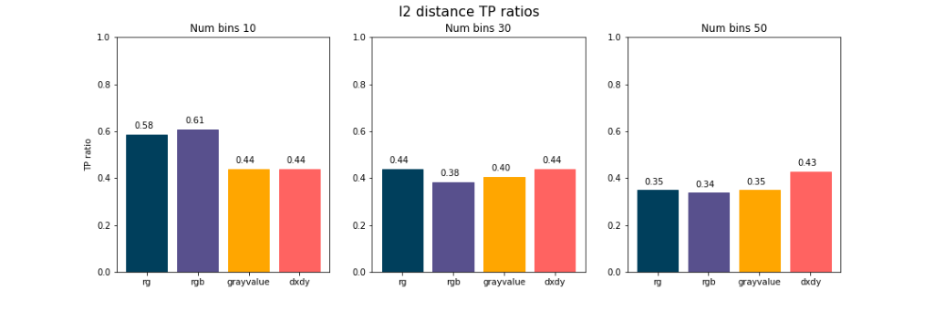

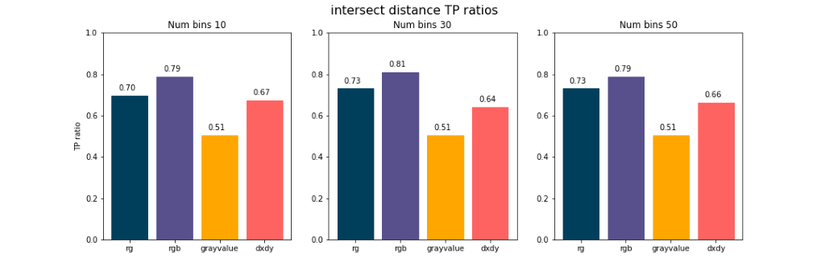

As we can see, the only reliable metric seems to be the intersect distance as a metric of similarity, that would be suggested by the stability of the metric across number of bins, having comparable performances across 10, 30 and 50. Also the TP ratio metric, the one for evaluating performance of the model, was best for intersection.

**FDS – ASSIGNMENT 1 – QUESTION 4-b**

If we define $δ$ as the distance between two images and $τ$ as a given threshold, then we can define the following two *quality measures*:

$Precision=\frac{TP}{TP+FP}$, $Recall=\frac{TP}{TP+FN}$, where

$$TP=Number of correct matches among images with δ ≤ τ$$

$$FP=Number of incorrect images with matches among images with δ ≤ τ$$

$$FN=Number of correct matches among images with δ > τ$$

Our goal is to maximize both for best performance, ideally while keeping the generalization of the model adequate (i.e., not overfitting).

We have a normalized distance, so by using a threshold we could indicate whether an image was close enough or not. The pair of images with a distance lower or equal than the threshold would be classified as a positive match, whereas for higher than threshold distances the model would not be indicated as a match.

As seen in the code, we first obtained the distance matrix of images. Then, for each threshold, we checked the distance and whether we had a true positive, false negative or false positive. To do so, we had a reference diagonal matrix for classification, where the matching images indices would be found on the diagonal itself; in other words, where $Q_{i,i}$ matches $M_{i,i}$.

As we can see in the plots, and as said before in exercise 3, the intersect distance seems to be the most reliable metric among the rest.

Also, we noticed that the "minimum score" given to the X^2 distance - see code, dist_module.py - influences the precision/recall curve, as shown below.

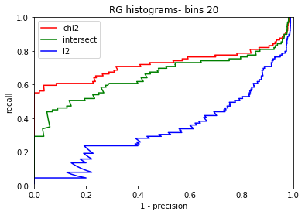

Lower values for the minimum score allow the recall to start from a better point, more than 0.5 in some cases.

Eventually, we present a study based on three different plots, showing results for different histograms (RGB, RG, and Dx/Dy), different distance types (chi2, l2 and intersect) and different number of bins.

In general, RGB histograms show a higher score for both recall and precision than RG and Dx/Dy histograms. The Dx/Dy histograms always show the worst performance with any different number of bins.

When the number of bins increases from 10 to 15, the RGB histograms also have a better performance, as shown in Fig. 2 and Fig. 5.

As we can see, intersect distance give the best performance on the RGB and RG histograms while it’s worse on Dx/Dy histograms. In each histogram, intersect distance has better results than l2 and chi2 distance types.

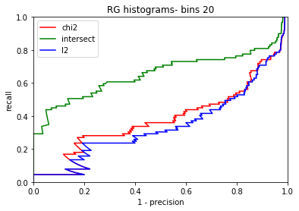

Figure 1 Recall/precision curve when using RG histogram – bins 20

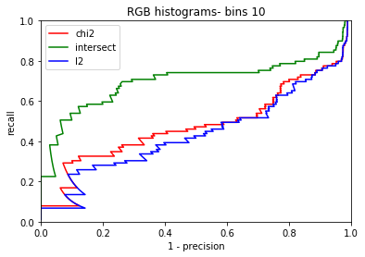

Figure 2 Recall/precision Curve when using RGB histograms – bins 10

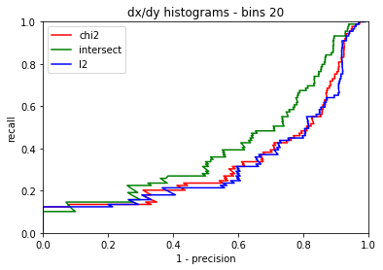

Figure 3 Recall/precision curve when using Dx/Dy histograms – bins 20

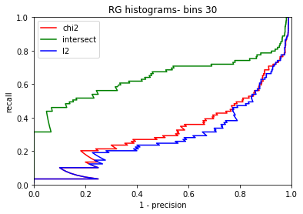

Figure 4 Recall/Precision Curve when using RG histograms - bin 30

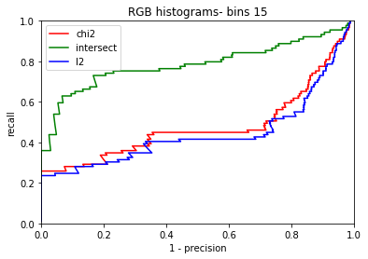

Figure 5 Recall/ Precision Curve when using RGB histograms - bins 15

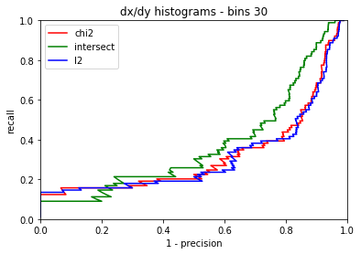

Figure 6 Recall/ Precision Curve when using Dx/Dy histograms - bins 30

**Authors:**

Giovanni Giunta

Mehrzad Jafari

Francesco Lauro

Marco Muscas